APP F110

Automatic Payment Program (APP) is functionality of posting accounts payable like payments to a vendor based on vendor invoices automatically. APP is used to find out due/overdue invoices and to process a list of vendor invoices to make payments in one go.

The Transaction code F110 is for managing automatic payments.

Automatic Payment Program is divided into 4 steps (4 P's) :

1. Parameter
2. Proposal
3. Payment
4. Print

Steps to Run APP:

Enter Run Date & Identification code

* Run Date: Enter the date for the transaction to run
* Identification: Enter a Five-character alphanumeric code that will be used to identify the payment program

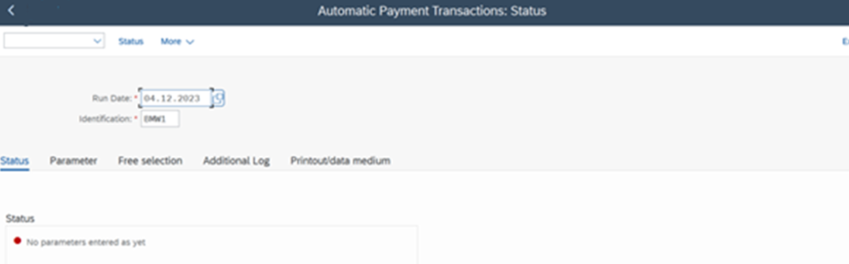

STEP 1 - PARAMETER

* What is to be paid – Docs. Entered Up to
* What payment methods will be used – Payment Methods
* When will the payments be made – Posting Date
* What is the next posting date: Telling to the system that I am planning to do the payment on this date and based on this date system will select invoices.
* Which company codes will be considered – Company Codes
* How are they going to be paid – Payment Method Sequence decides the Priority of the Payment Method(Ranking order)

Save Parameters

STEP 2 : PROPOSAL

* In this step, the system performs a proposal run to identify the invoices that meet the selection criteria defined by the user. The criteria may include parameters such as due dates, company codes, vendor groups, or other factors.
* During the proposal run, the system proposes a list of payments that can be made based on the specified criteria. Users can review this proposal before proceeding to the next step.

After the Parameters are Entered we execute the Program by clicking the proposal button in Application Toolbar

The APP performs a proposal run to identify the invoices that meet the specified selection criteria. During this run, the system proposes a list of payments that can be made based on the defined parameters.

After the proposal run, users can review and adjust the payment proposal. They can exclude certain invoices, change payment amounts, or make other adjustments before proceeding to the actual payment run.

Edit Proposal

* After the proposal run, users can review and edit the payment proposal. In this step, they can adjust the proposed payments, exclude certain invoices, change payment amounts, or add additional invoices.
* The goal is to ensure that the payment proposal accurately reflects the organization's payment requirements before the actual payment run.

The system will show two types of list:

1. Exception List (\*)
2. Payment List (\*)

Select exception list supplier 100101.

Add Bank Details Payment Method (R) House Bank (ICICI) Account ID (ICICI) and continue.

Exception list "100101" is turned to PAYMENT list

STEP 3 : PAYMENT RUN

* Once the payment proposal has been reviewed and finalized, the system executes the payment run. During this step, payment documents are generated, accounting entries are posted, and the payment file is prepared for transmission to the bank.
* The payment run involves the creation of payment media (checks, electronic fund transfers, etc.) and the posting of accounting entries to reflect the outgoing payments in the financial system.

Once the payment proposal is confirmed, the system executes the payment run. This involves generating payment documents, creating accounting entries, and preparing the payment file for transmission to the bank.

STEP 4: PRINT

INFORMATION TO VENDOR & CUSTOMER

* After the payment run is completed, the next step involves printing the payment media or transmitting electronic payment files to the bank. The method of transmission depends on the chosen payment method (e.g., checks, electronic funds transfer).
* Users can use the SAP Payment Medium Workbench (PMW) to review and manage payment media. This step ensures that the necessary documents are sent to vendors or that electronic payments are transmitted to the bank.